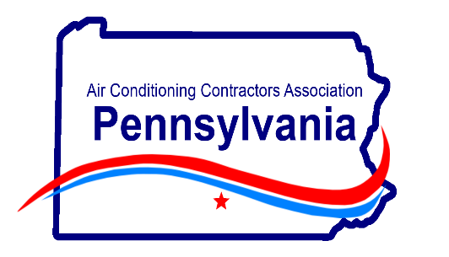
Your Presenter -Marc Faulkner, Faulkner Inspection Services , PA DOL Third-Party Agency #A00403

Monday, May 18 – ZOOM Virtual Training – 8am-10am
Topic: “PA Code changes for HVAC Contractors”
This presentation is an overview of the new codes which went into effect January 1, 2026. An overview of codes applicable to HVAC installations will be presented including paths available for energy code compliance. The presentation focuses predominately on selected changes made to the ICC codes from the 2018 to the 2021 ICC code editions specific to the mechanical, energy and electrical code provisions. A review of the PA amendments to the ICC codes is included as well as a discussion on when the new codes become legally enforceable.
Applicable codes: 2021 International Residential Code, 2021 International Energy Conservation Code, 2025 Pennsylvania Alternative Residential Energy Provisions.
COST: Member - $50.00 Non-Member - $75.00
Send checks to: PAACCA c/o Sue Morris
994 Old Eagle School Rd., Ste. 1019, Wayne, PA 19087
Attendee: ______________________________________________________
Email: _________________________________________________________
Payment: CC# ___________________________________________________
CVV: ____________Expiration: _______________
After payment, a ZOOM invite will be sent to each attendee to register for the call.
Any questions, please contact Sue at 610-971-4850

